**QR Concert Booking System Setup**

**Prerequisites**

Before you begin, ensure that you have the following prerequisites installed on your system:

* Node.js (version 14 or above)
* npm (Node.js package manager) or Yarn

To verify the installation, open a terminal or command prompt and run the following commands:

node -v

npm -v

Ensure that Node.js and npm are installed and properly configured.

Installation

1. **Clone the Repository**: Clone the QR Concert Booking System repository to your local machine.

git clone <repository-url>

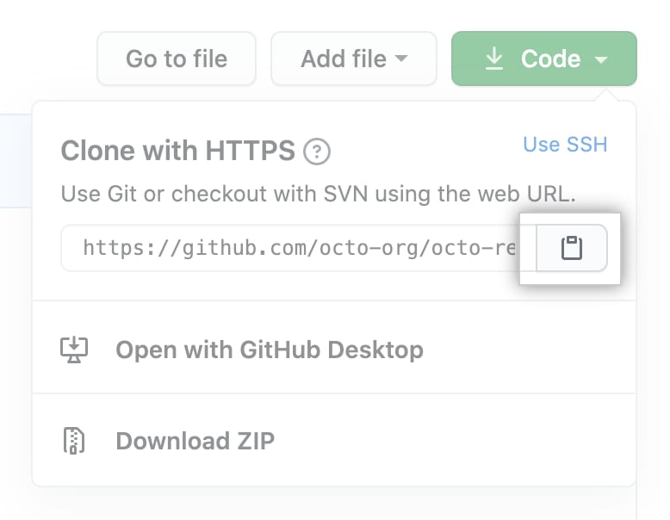

Replace **<repository-url>** with the URL of the repository.

1. **Backend Setup**:

* Navigate to the **backend** directory.
* Install backend dependencies.

cd backend

npm install

* Set up the MySQL database using the provided SQL schema.
* Configure the database connection in **backend/QRTicket.js** and **backend/server.js**.
* Start the backend server.

node server.js



1. **Frontend Setup**:

* Navigate to the **frontend** directory.
* Install frontend dependencies.

cd ../frontend

npm install



* Edit components if necessary.
* Build the frontend application.

npm run build



1. **Serve the Application**:

* Copy the contents of the **dist** directory generated in the **frontend** folder.
* Paste the copied contents into the **backend** directory, replacing any existing files.
* Change directory to the **backend**.
* Start the backend server to serve the frontend files.

node server.js

1. **Access the Application**:

* Open your web browser and navigate to **http://localhost:3000** or the specified port where the backend server is running.

By following these steps, you can set up and run the QR Concert Booking System on your local machine.

